LAB TASK #8

TASK #1

#include <iostream>

using namespace std;

int main()

{

For (int i=1;i<=5;++i)

{

for (int j=1;j<=i;++j)

cout<<"\*";

cout<<endl;

}

system("pause");

return 0;

}

Output

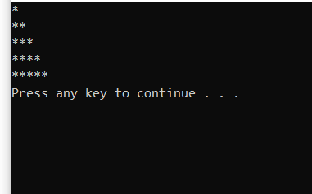

TASK #2

#include<iostream>

using namespace std ;

int main ()

{

int size ;

cout<<"Enter size : ";

cin>>size;

for(int i = 1 ; i<=size ; size--)

{

for (int j = size ; j > 0 ; j--)

cout<<"\*";

cout<<endl;

}

system("pause");

return 0 ;

}

OUTPUT

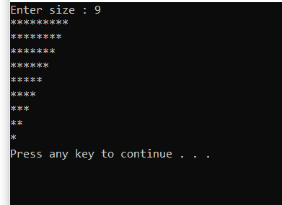

Task #10

Code:

#include <iostream>

 using namespace std;

 int main()

 {

 int i, j, k;

 cout << " Input number of rows (half of the diamond): ";

 cin >> k;

 for (i = 0; i <= k; i++)

 {

 for (j = 1; j <= k - i; j++)

 cout << " ";

 for (j = 1; j <= 2 \* i - 1; j++)

 cout << "\*";

cout << endl;

 }

 for (i = k - 1; i >= 1; i--)

{ for (j = 1; j <= k - i; j++)

 cout << " ";

for (j = 1; j <= 2 \* i - 1; j++)

 cout << "\*";

cout << endl;; }

system("pause");

return 0;

}

Output

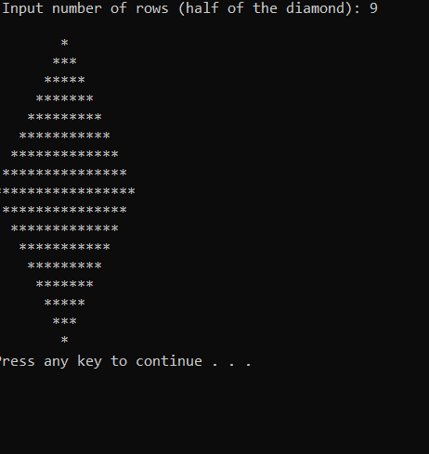

Task #3

#include <iostream>

using namespace std;

int main()

{

for (int i = 1; i<= n; i++)

{

for (int k = n - i; k > 0; k--)

cout << " ";

for(int j=1; j<=i;j++)

{

cout << "\*";

}

cout << endl;

system("pause");

return 0;

}

Task #11

Code:

#include<iostream>

using namespace std;

int main()

{

cout<<"Enter size of Daimond: ";

int size;

cin>>size;

int z=1;

for ( int i=0; i<=size; i++)

{

for (int j=size; j>i; j--)

{

cout<<" ";

}

cout<<"\*";

if ( i>0)

{

for ( int k=1; k<=z; k++)

{

cout<<" ";

}

z+=2;

cout<<"\*";

cout<<endl;

}

z-=4;

for (int i=0; i<=size-1; i++)

{

for (int j=0; j<=i; j++)

{

cout<<" ";

}

cout<<"\*";

for (int k=1; k<=z; k++)

{

cout<<" ";

}

z-=2;

if (i!=size-1)

{

cout<<"\*";

}

cout<<endl;

}

System(“pause”);

return 0;

}

Output:

